Qhayisa S CWAYI,  Tshwane University of Technology,  Aubrey Matlala Road, Soshanguve, 0152, South Africa  Tel: +27 65 933 1687,  Email: 212451096@tut4life.ac.za | Tlou J RAMABU,  Tshwane University of Technology,  Aubrey Matlala Road, Soshanguve, 0152, South Africa  Tel: +27 12 382 9837,  Email: ramabutj@tut.ac.za | Daniel CHUENE,  Tshwane University of Technology,  Aubrey Matlala Road, Soshanguve, 0152, South Africa  Tel: +27 12 382 0001,  Email: chuenend@tut.ac.za | Vatiswa M BOOI  Tshwane University of Technology,  Aubrey Matlala Road, Soshanguve, 0152, South Africa  Tel: +27 12 382 1200,  Email: booivm@tut.ac.za
Challenges and Trends in Socio-Technical Models aimed at Mitigating Human Vulnerability to Social Engineering: A Systematic Literature Review

Abstract - Social engineering attacks remain a critical cybersecurity challenge as they primarily exploit human psychological vulnerabilities rather than technical system flaws. This systematic literature review investigates contemporary socio-technical mitigation models designed to reduce human susceptibility to these exploits. Adhering to the PRISMA 2020 for Abstracts guidelines, a structured search was conducted across major databases including IEEE Xplore, Scopus, and ACM Digital Library. The review synthesized findings from eleven primary studies, identifying a range of approaches from behavioral modeling to gamified learning systems. The results indicate that while these models improve resilience, they are often hindered by fragmented frameworks and limited long-term behavioral change. Ultimately, this study highlights a necessary shift toward adaptive, context-aware cybersecurity strategies to provide a more robust defense against evolving threats.
Index Terms - Social Engineering, Human Vulnerability, Mitigation, Socio-Technical Models, Phishing, Security Awareness
1. Introduction
Social engineering (SE) represents one of the most significant cybersecurity threats because it exploits human psychology rather than technological vulnerabilities [1], [2]. Techniques such as phishing, vishing, and pretexting manipulate individuals into disclosing sensitive information or performing actions that compromise security systems. Recent cybersecurity reports show that a large proportion of cyber incidents involve a human element, demonstrating that users remain a critical vulnerability within organizational security environments [4], [5]. As attackers increasingly employ artificial intelligence tools to generate convincing fraudulent communications, traditional technical defenses alone are insufficient [3]. To address this challenge, researchers have proposed socio-technical mitigation models that combine technological defenses with human-centered security strategies [11], [12]. However, existing research remains fragmented and lacks a consolidated understanding of effective mitigation approaches. This study therefore conducts a systematic literature review to analyze existing socio-technical mitigation models and identify key challenges, trends, and future research directions.
This systematic review addresses this gap by examining the current research landscape on socio-technical models that mitigate human vulnerability to social engineering. The study is guided by three central research questions: What key challenges and observable trends influence the development and implementation of socio-technical models for reducing human susceptibility to social engineering? What types, components, strengths, and limitations characterize existing socio-technical models designed to protect individuals from such attacks? And finally, what future research directions emerge from the current body of literature on human vulnerability and socio-technical mitigation strategies? To address these questions, the review pursues two primary research objectives: to investigate and categorize the current and emerging challenges and trends associated with mitigating human susceptibility to social engineering, and to evaluate the strengths, limitations, and core components of existing socio-technical mitigation models reported in the literature. Together, these research questions and objectives provide a structured foundation for understanding the complexities of human-centered security within socio-technical contexts.
2. Methodology
This study employs a Systematic Literature Review (SLR) approach guided by the PRISMA framework [6]. The review process followed four stages: identification, screening, eligibility assessment, and final inclusion of relevant studies. A structured search strategy combining keywords related to social engineering, human vulnerability, and mitigation frameworks was applied across major academic databases including Scopus, IEEE Xplore, Web of Science, and the ACM Digital Library. Inclusion criteria required studies to be peer-reviewed, written in English, and focused on mitigation models integrating human and technical security components. Studies focusing solely on technical detection mechanisms or attack classification were excluded. The final dataset consisted of eleven studies that met the predefined inclusion criteria.
2.1 Study Selection Process
The study selection process followed the four-stage procedure defined by the PRISMA framework, which includes identification, screening, eligibility assessment, and final inclusion of relevant studies. The objective of this process was to systematically filter the retrieved literature to ensure that only studies relevant to socio-technical mitigation models for social engineering were included in the final analysis [3], [12].
During the identification phase, the search strategy was applied across the selected academic databases, including Scopus, IEEE Xplore, Web of Science, and the ACM Digital Library. This initial search produced a set of potentially relevant records related to social engineering, human vulnerability, and mitigation frameworks.
In the screening phase, duplicate records were removed, and the remaining studies were evaluated based on their titles and abstracts. Studies that did not focus on social engineering mitigation or that lacked a socio-technical perspective were excluded at this stage.
The eligibility phase involved a full-text review of the remaining articles to determine whether they met the predefined inclusion criteria. Studies that focused solely on technical security mechanisms or that did not propose or evaluate a mitigation model were excluded.
After applying all screening criteria, a final set of eleven studies was selected for inclusion in the systematic review. These studies form the basis of the descriptive and thematic analyses presented in the following sections.
The complete study selection process is illustrated in the PRISMA flow diagram shown in Figure 1, which summarizes the number of records identified, screened, excluded, and included in the final review.
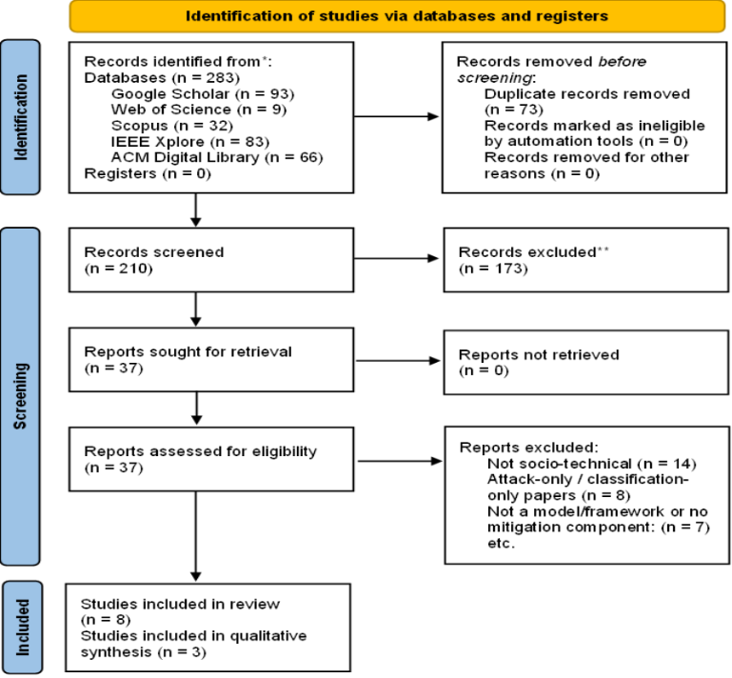
Figure 1: PRISMA flow diagram
2.2 Descriptive Analysis of Included Studies
A descriptive analysis was conducted to examine the general characteristics of the studies included in the review. This analysis provides an overview of the publication trends, research focus areas, and distribution of the selected literature.
The included studies were published between 2019 and 2025, reflecting the growing research interest in human-centered cybersecurity and sociotechnical mitigation strategies for social engineering attacks. The increase in publications in recent years suggests that researchers are increasingly recognizing the importance of addressing the human element in cybersecurity.
In terms of publication outlets, the selected studies consist of both journal articles and conference papers, indicating that the topic is actively discussed across multiple research venues within the cybersecurity and information systems communities.
Geographically, the studies originate from a variety of regions, including North America, Europe, and Asia, highlighting the global relevance of social engineering threats and the need for interdisciplinary mitigation strategies. The diversity of research contexts also reflects the widespread recognition of human vulnerability as a critical cybersecurity concern.
To provide transparency and traceability, the essential characteristics of each included study are summarized in Table 1, which outlines the proposed model or framework, the evaluation method used, and the key contributions reported by the authors.
3. Results
The execution of the search strategy across the selected electronic databases initially produced a substantial corpus of literature, which was subsequently subjected to a rigorous multi-stage screening process. Following the removal of duplicate records, the remaining titles and abstracts were evaluated against the predetermined inclusion and exclusion criteria. A comprehensive full-text review followed, resulting in the final selection of eleven primary studies deemed suitable for synthesis. These studies reflect a broad geographical and sectoral distribution, providing a holistic overview of contemporary socio-technical methodologies in the domain of social engineering mitigation. The outstanding characteristics of the included research encompassing specific framework architectures, evaluation protocols, and primary scholarly contributions are systematically synthesized in Table 1.
Table 1: Summary of Included Studies and Key Contributions
Author(s) & Year | Model / Framework | Evaluation Method | Key Contribution
Johnson et al. (2022) | Persuasion Resistance Model (PRM) | Field Experiment | Demonstrates that targeted training reduces phishing susceptibility over time
Chen & Wang (2023) | Socio-Technical Risk Assessment Framework | Case Study (Finance Sector) | Quantifies the gap between user knowledge and actual behaviour
Rodriguez (2021) | Gamified Phishing Training System | Laboratory Experiment | Improves engagement and reduces phishing click rates
Wilson (2020) | Experiential Learning Model | Experimental Study | Enhances user learning through simulation-based training
Al-Mabruk & Hassan (2023) | Gamified Experiential Learning Framework | Controlled Study | Strengthens resilience through interactive learning approaches
Adams (2023) | Adaptive Socio-Technical Defense Model | Conceptual + Simulation | Introducing adaptive mitigation mechanisms
Johnson & Wu (2023) | AI-Driven Adaptive Mitigation Model | Experimental Evaluation | Uses ML for real-time phishing detection and response
Garcia & Diaz (2021) | Integrated Socio-Technical Model | Case Study | Combines organizational policy and technical controls
Chen et al. (2018) | Security Awareness Training Model | Survey-Based Study | Evaluates impact of training on security culture
Jones et al. (2019) | Behavioural Susceptibility Model | Statistical Analysis | Identifies cognitive predictors of phishing susceptibility
Kowalski & Smith (2021) | Psychological Resistance Framework | Experimental Study | Focuses on cognitive bias mitigation strategies

3.1 Thematic Classification of Socio-Technical Mitigation Models
To synthesize the findings of the systematic review, the included studies were categorized based on their primary research focus and the type of mitigation approach proposed. Through an iterative analysis of the selected literature, five dominant thematic categories of socio-technical mitigation models were identified.
Behavioral and Psychological Models
Behavioral and psychological models focus on understanding the cognitive biases, emotional triggers, and decision-making processes that influence individuals’ susceptibility to social engineering attacks [1], [4]. These studies emphasize the role of psychological theories and behavioural analysis in designing mitigation strategies that improve users’ ability to recognize and resist manipulation attempts.
Security Awareness and Training Models
Security awareness and training (SAT) models emphasize educational interventions designed to improve users’ knowledge of cybersecurity threats [7]. These approaches often involve structured training programs, phishing simulations, and awareness campaigns aimed at improving individuals’ ability to identify and respond to suspicious communications.
Gamified and Experiential Learning Models
Gamified mitigation models introduce interactive and scenario-based learning techniques to enhance user engagement and knowledge retention [8], [9]. By incorporating elements such as simulations, challenges, and reward mechanisms, these models aim to create immersive training environments that allow users to practice identifying social engineering attacks in realistic scenarios.
Integrated Socio-Technical Frameworks
Integrated socio-technical frameworks aim to combine human-centered approaches with technological security controls [11], [12]. These models typically incorporate multiple layers of defence, including organisational policies, behavioural monitoring mechanisms, and automated security systems designed to support human decision-making.
AI and Machine Learning–Driven Adaptive Mitigation
Recent research has begun exploring the use of artificial intelligence and machine learning techniques to develop adaptive mitigation systems [13], [14]. These approaches leverage behavioural analytics and contextual data to dynamically adjust security responses based on user behavior, environmental factors, and emerging threat patterns.
The thematic classification of the reviewed literature provides a structured understanding of the various strategies proposed for mitigating human vulnerability to social engineering attacks. This classification also highlights the increasing shift toward adaptive and human-centric cybersecurity approaches, which aim to integrate technological innovation with behavioural security practices.
The analysis of the reviewed studies revealed five major categories of socio-technical mitigation models. These categories include behavioral models, security awareness training approaches, gamified learning systems, integrated socio-technical frameworks, and AI-driven adaptive mitigation models. The classification of these mitigation approaches is illustrated in Fig. 3.
4. Discussion
The findings of this study highlight several critical challenges in the design and implementation of socio-technical mitigation models for social engineering attacks. One major challenge is the lack of standardized frameworks that effectively integrate human, organizational, and technological components [3]. Many existing approaches address these components in isolation, limiting their overall effectiveness in real-world environments.
Another key challenge is the difficulty of sustaining long-term behavioural change among users. While security awareness training programs can improve short-term awareness, their effectiveness often diminishes over time without continuous reinforcement [7]. This suggests that static training approaches are insufficient for addressing evolving social engineering threats.
Furthermore, the increasing sophistication of social engineering attacks, particularly those enhanced by artificial intelligence, presents a significant challenge for traditional mitigation strategies. Attackers are now able to generate highly convincing phishing messages and impersonation attacks, making it more difficult for users to distinguish between legitimate and malicious communications [13], [14].
Despite these challenges, literature reveals several important trends. There is a clear shift toward adaptive and context-aware mitigation systems, which dynamically adjust security responses based on user behaviour and threat intelligence. Additionally, the integration of behavioural analytics and machine learning techniques is enabling more proactive detection of user vulnerabilities.
The findings also indicate that effective mitigation requires a holistic socio-technical approach that combines behavioural insights, continuous training mechanisms, and technological controls. This reinforces the need for integrated frameworks that address the complexity of human-centered cybersecurity threats.
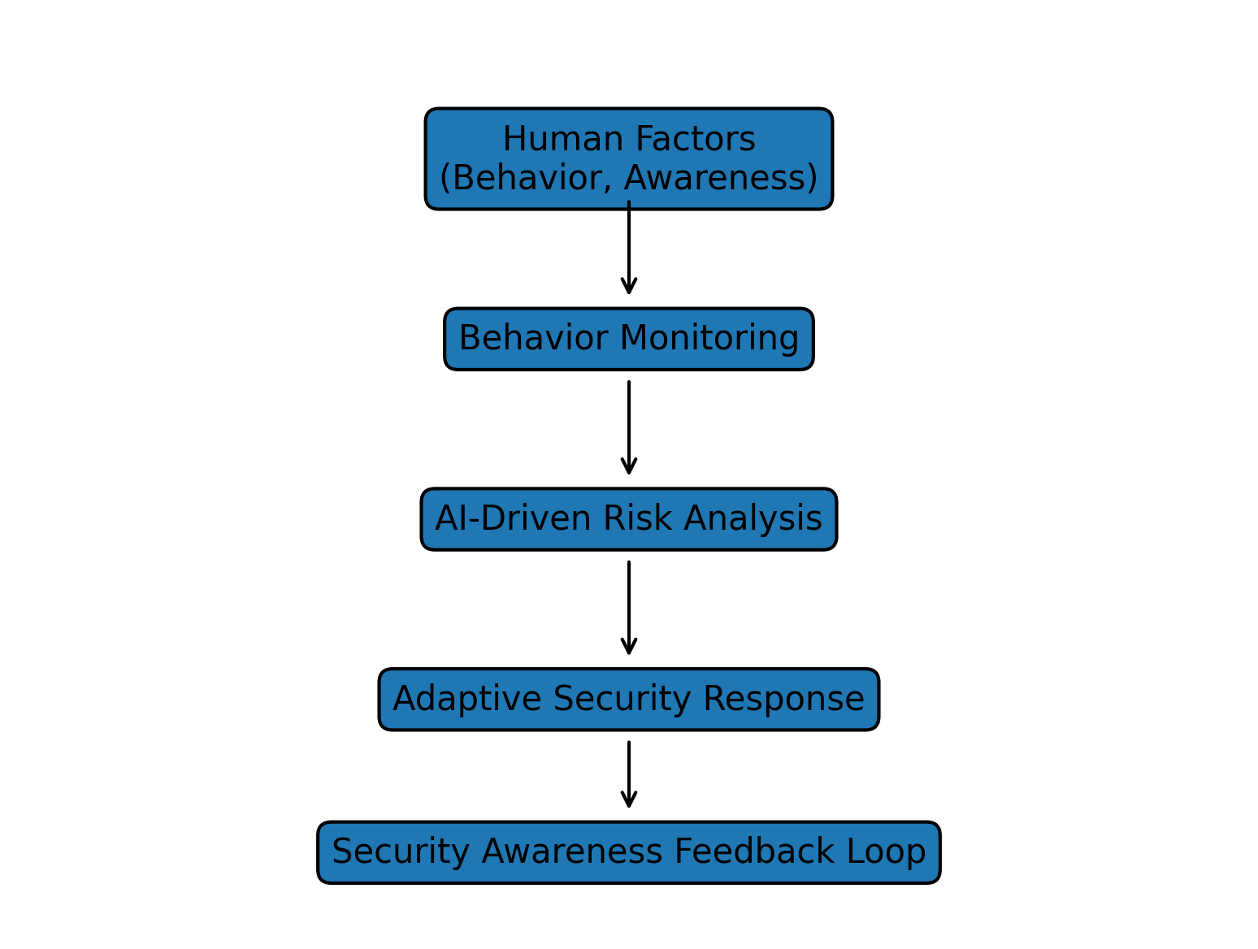
Figure 2: Conceptual Socio‑Technical Mitigation Model
5. Findings
The analysis of the selected studies reveals several critical themes regarding the current landscape of social engineering mitigation, specifically concerning the nature of the problems faced and the solutions currently being deployed.
5.1 Trending Socio-Technical Problems
A significant trending problem identified in the literature is the persistence of human-centric vulnerabilities, where technical controls fail because attackers successfully exploit psychological triggers such as trust, urgency, and authority. Furthermore, the sustainability of training remains a major challenge, research indicates a decay in knowledge where users frequently revert to insecure behaviors over time despite completing security awareness programs. This issue is compounded by the presence of fragmented frameworks. Many current models are either overly focused on technical aspects or purely behavioral, failing to achieve a seamless integration where technology effectively supports human decision-making in real-time.
5.2 Existing Socio-Technical Solutions
In response to these challenges, several existing solutions have gained prominence, most notably gamified experiential learning. These systems move beyond static instruction by using simulations to allow users to experience and identify phishing attacks in a controlled environment. Additionally, researchers are increasingly incorporating behavioral modeling, utilizing psychological theories such as Protection Motivation Theory to predict and nudge safer user actions. More recently, the field has seen the emergence of adaptive socio-technical systems. These advanced models are designed to be context-aware, dynamically adjusting security protocols and interventions based on a user’s immediate environment and observed vulnerability level.
The synthesis of these findings is consolidated in Table 2, which maps the trending socio-technical problems against the specific solutions developed within the reviewed frameworks. This structured comparison provides the necessary evidence to evaluate the current effectiveness of mitigation strategies in the face of evolving human-centric threats.
Table 2: Comparative Analysis of Socio-Technical Mitigation Models
Model Type | Strengths | Limitations | Applicability
Behavioral Models | Addresses cognitive vulnerabilities | Limited technical integration | User-focused environments
Security Awareness Training | Improves user knowledge | Poor long-term retention | Organizational training programs
Gamified Learning | High engagement and retention | Resource-intensive | Training platforms
Socio-Technical Frameworks | Holistic integration | Complex implementation | Enterprise systems
AI-Driven Models | Adaptive& real-time response | Require large datasets | Advanced cybersecurity systems

The thematic classification of the reviewed literature, as illustrated in Figure 3, provides a structured understanding of the various strategies proposed for mitigating human vulnerability. The distribution shows a significant emphasis on gamified and experiential learning (27.3%), with a balanced focus across behavioral models, traditional training, integrated frameworks, and emerging AI-driven solutions (18.2% each). This visual representation highlights the increasing academic shift toward human-centric approaches that prioritize engagement and real-time adaptation over static instructional methods.
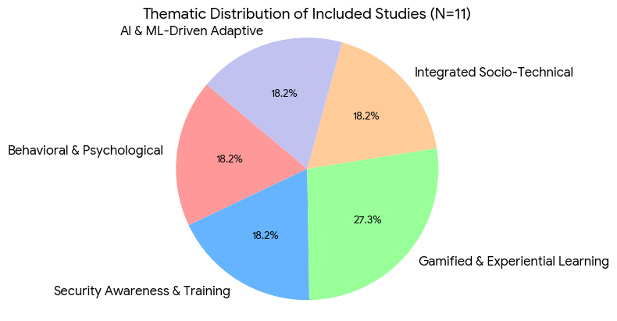
Figure 3: Thematic distribution of the 11 included studies across socio-technical mitigation categories.
6. Future Research Directions
The findings of this systematic literature review underscore the critical necessity of evolving from static security interventions toward more dynamic, human-centric defenses. While current research has established a foundational understanding of socio-technical mitigation, several avenues for future investigation remain. First, there is a clear requirement for longitudinal studies that assess the long-term sustainability of behavioral changes induced by gamified and experiential learning models. Current evidence suggests a "decay" in security awareness over time, and future research must address how to maintain high levels of vigilance without causing security fatigue.
Furthermore, the integration of artificial intelligence and machine learning presents a significant opportunity to develop adaptive mitigation systems that can respond to real-time psychological triggers. Future studies should focus on the ethical implications and technical feasibility of context-aware models that monitor user behavior to provide just-in-time interventions. Additionally, research should expand to investigate the cross-cultural effectiveness of these models, ensuring that socio-technical defenses are robust across diverse organizational and regional contexts. By addressing these gaps, the academic community can move toward a unified framework that seamlessly integrates human behavioral insights with advanced technological safeguards.
7. Conclusion
This systematic literature review has synthesized the current state of socio-technical models designed to mitigate human vulnerability to social engineering. By analyzing eleven primary studies, the review identified a clear shift in the research landscape from traditional, one-size-fits-all training programs toward sophisticated, adaptive, and gamified interventions. The results emphasize that technical controls alone are insufficient to counter threats that exploit human psychology; rather, effective defense requires a holistic integration of behavioral insights and technological innovation.
The thematic classification provided in this study offers a structured roadmap for researchers and practitioners to identify effective strategies, particularly highlighting the potential of AI-driven and experiential learning models. In conclusion, mitigating the risk of social engineering necessitates a paradigm shift where the human element is viewed not as the "weakest link," but as an empowered and supported component of a multi-layered security architecture. This study provides the consolidated evidence necessary to inform the development of more resilient, context-aware cybersecurity defenses in an increasingly complex threat environment.
8. Reference
[1] S. M. Albladi and G. R. S. Weir, “A study on the psychology of social engineering-based cyberattacks,” Applied Sciences, vol. 12, no. 4, p. 2060, 2022.
[2] C. Hadnagy, S. Wilson, and P. Wilson, “An interdisciplinary view of social engineering: A call to action,” Computers & Security, vol. 105, p. 102240, 2021.
[3] H. Jahankhani, S. Kendzierskyj, and R. Montasari, “Social engineering attack mitigation models: A review,” Cybersecurity Research Journal, vol. 10, no. 4, pp. 101–119, 2022.
[4] K. Parsons, A. McCormac, M. Butavicius, M. Pattinson, and C. Jerram, “Human factors and information security: Individual, culture, and environmental influences,” Computers & Security, vol. 70, pp. 83–94, 2017.
[5] Verizon, “2024 Data Breach Investigations Report,” 2024. [Online].
[6] S. Wenni et al., “Social engineering attacks prevention: A systematic literature review,” IEEE Xplore, 2022.
[7] W. He and Y. Zhang, “Employee training effectiveness in mitigating social engineering attacks,” Journal of Cybersecurity Education, vol. 6, no. 2, pp. 45–60, 2019.
[8] A. Al-Mabruk and K. Hassan, “Gamified experiential learning to strengthen user resilience against phishing attacks,” International Journal of Information Security Education, 2023.
[9] L. Rodriguez, “Gamified phishing training system for improving organizational security,” Computers & Security, vol. 100, 2021.
[10] V. Jacob and M. Diane, “Vulnerabilities of elderly populations to social engineering,” 2023.
[11] R. Gomes, L. Reis, and B. Alturas, “Phishing and socio-technical attacks: Trends and prevention,” Journal of Information Security, vol. 12, no. 3, pp. 210–225, 2023.
[12] S. Wang, J. Sun, and Q. Zhu, “Socio-technical approaches in cybersecurity,” Journal of Cyber Defence Research, vol. 11, no. 2, pp. 90–108, 2024.
[13] M. Sowjanya, “Artificial intelligence in cybersecurity: Opportunities and risks,” Journal of Emerging Technologies, vol. 15, no. 1, pp. 7–22, 2023.
[14] B. Thuraisingham, “AI-driven cybersecurity: Threat detection and countermeasure frameworks,” Journal of Information Security, vol. 11, no. 1, pp. 1–15, 2020.

